Part 2

Q1:

Given the following definitions;

x, y, z = 3, 5, 7

Evaluate the following Boolean expressions:

* x == 3 ----------- True
* x < y ---------------- True
* x >= y --------------- False
* x <= y --------------- True
* x != y - 2 ------------ False
* x < 10 ---------------- True
* x >= 0 and x < 10 -------------True
* x < 0 and x < 10 --------------- False
* x >= 0 and x < 2 --------------- False
* x < 0 or x < 10 --------------True
* x > 0 or x < 10 --------------True
* x < 0 or x > 10 --------------False

Q2:

Given the following definitions:

x, y = 3, 5

b1, b2, b3, b4 = True , False , x==3, y < 3

evaluate the following Boolean expressions:

* b3 ------------- True
* b4 -------------- False
* not b1 ---------False
* not b2 ---------True
* not b3 ---------False
* not b4 ---------True
* b1 and b2 --------- False
* b1 or b2 -----------True
* b1 and b3 ------------ True
* b1 or b3 --------------- True
* b1 and b4 -------------- False
* b1 or b4 -------------- True
* b2 and b3 ------------- False
* b2 or b3 ---------------True
* b1 and b2 or b3 -------------True
* b1 or b2 and b3 -------------True
* b1 and b2 and b3 ------------ False
* b1 or b2 or b3 ----------------True
* not b1 and b2 and b3 --------False
* not b1 or b2 or b3 ------------True
* not (b1 and b2 and b3) ----------True
* not (b1 or b2 or b3) -------------- False

Q3:

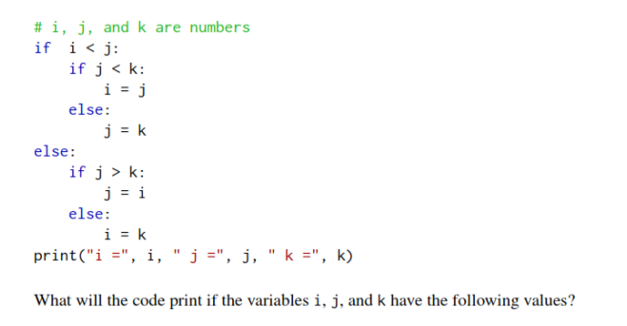

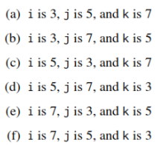

: i = 5, j = 5 , k = 7

: i = 3, j = 5 , k = 5

: i = 7, j = 3 , k = 7

: i = 5, j = 3 , k = 3

: i = 5, j = 3 , k = 5

: i = 7, j = 7 , k = 3

Q4:

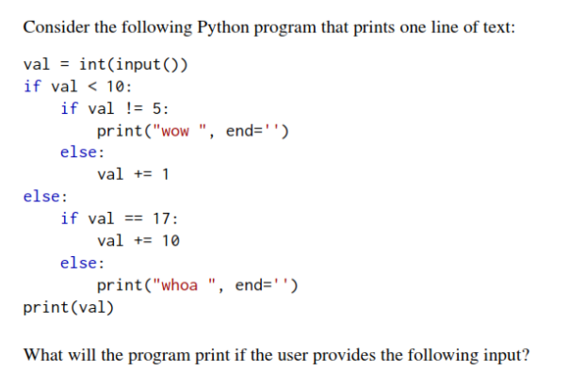

* 3 --------------- wow 3
* 21 ---------------whoa 21
* 5 -----------------6
* 17 ------------------ 27
* -5 ---------------- wow -5

Q5:

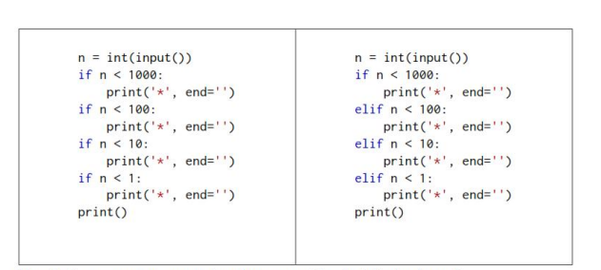

How do the two program react when the user provides the following inputs?

PROGRAM 1

* 0 ---------------- \*\*\*\*
* 1 --------------- \*\*\*
* 5 --------------- \*\*\*
* 50 -------------- \*\*
* 500 -------------- \*
* 5000 --------------

PROGRAM 2

* 0 --------------- \*
* 1 ------------ \*
* 5 ----------- \*
* 50 ---------- \*
* 500 ------------- \*
* 5000 -------------

Why do the two programs behave as they do?

Because if statement always gets check whether the condition is true or not .it will check all if statements.

if there are multiple if and else statements it well check whether the condition is true or false they it will run from if to else.